Coal: Definition and Major Types
By Kirin Peagler

Within this chapter I will discuss the usage and archaeological importance of coal as an artifact. I will focus specifically on the manufacture and use of coal in the Rhode Island area as well as a history of the coal beds and mining operations within the state. A brief analysis of the different types of coal and their properties will also be given.

Coal is defined as a “fossil fuel extracted from the ground through underground mining or surface-mining”. (http://en.wikipedia.org/wiki/Coal) It is a highly combustible sedimentary rock that is mainly composed of carbon along with other elements including hydrogen, oxygen, and nitrogen. It is of vegetable origin and was formed in swamp-like ecosystems located in lowland sedimentary basins. These areas are often called “coal forests” due to their massive production of coal. These coal forests are a result of the transformation of wood and other vegetable materials through the elimination of oxygen and hydrogen in larger amounts than the elimination of carbon. This transformation results from extreme pressures and temperatures which separate the organic matter into carbon, hydrogen, and oxygen. The variation in the degree of change from organic material to hard coal is a result of time factors, depth and disturbances of the coal beds, and the introduction of foreign matter. However, the main and most important factor in the evolution of coal is the presence (or absence) of disturbance within the crust of the earth’s surface in or near a coal field during the period of transformation. Disturbances of this type can affect the amount of foreign and incombustible matter found in coal and can determine to which category the coal belongs. (Ashley 1915)
Coal is ranked into categories based upon the differences within coals during different states of transformation. These changes are noted by a decrease in moisture, volatile matter, and oxygen and an increase in fixed carbon, sulfur, and sometimes ash. There are six ranks of coal that are currently recognized by the United States Geological Survey: Lignite, Sub-Bituminous, Bituminous, Semi-Bituminous, Semi-Anthracite, and Anthracite. The following table shows these ranks followed by the amount of fixed carbon, volatile matter, and moisture content.
RANK | Fixed Carbon % | Volatile Matter % | Moisture Content % | Calorific Value Btu/lb
Lignite | 37.80 | 18.80 | 43.40 | 7,400
Sub-Bituminous | 42.4 | 34.2 | 23.4 | 9,720
Low-Rank Bituminous | 47.00 | 41.40 | 11.60 | 12,880
Medium-Rank Bituminous | 54.2 | 40.80 | 5.00 | 13,880
High-Rank Bituminous | 64.60 | 32.20 | 3.20 | 15,160
Low-Rank Semi-Bituminous | 75.00 | 22.00 | 3.00 | 15,480
High-Rank Semi-Bituminous | 83.40 | 11.60 | 5.00 | 15,360
Semi-Anthracite | 83.80 | 10.20 | 6.00 | 14,880
Anthracite | 95.60 | 1.20 | 3.20 | 14,440

Table 13.1: Chemical Compositions of the Recognized Coal Ranks (http://energyconcepts.tripod.com/energyconcepts/classificton_of_us_coals.htm)

Lignite is a coal form within the early stages of transformation from peat to bituminous coal. It is brown and has a very wood-like appearance. Due to its high moisture content (30-45%) it disintegrates faster than other types of coal. Because of its rapid rate of disintegration, Lignite must be stored very carefully to avoid spontaneous combustion. It has been used in gas production and can be burned in bed combustion furnaces.
Sub-Bituminous coals are often called “black lignites” due to their black color and similar tendency to spontaneous combust. Sub-Bituminous coal is most often used in the areas where it is mined and can be used as a clean domestic fuel.
Bituminous coal is representative of the largest division of classified coals. It is also the widest in range in terms of chemical composition. The Bituminous rank encompasses gas coals, cannel coal, and local groups of coal known as “block” and “splint” coals.
Semi-Bituminous coal has a very high ratio of fixed carbon which allows for nearly smokeless combustion. It also has a higher calorific value than coals within any other rank. Semi-Bituminous coal was burned for the generation of steam and electricity prior to the invention of pulverized coal combustion. It is typically found in the Eastern coal fields although some has been found in Western areas.
Semi-Anthracite is a hard coal that overlaps the Semi-Bituminous coal description. It is a very rare form of coal to find in the United States and has little importance in terms of commercial purposes.
Anthracite is a hard coal that is primarily mined in eastern Pennsylvania. It is believed that the concentration of anthracite in Pennsylvania is a result of the intense transformations that affected the area. It was originally used as a domestic fuel or wherever smokeless combustion was required.

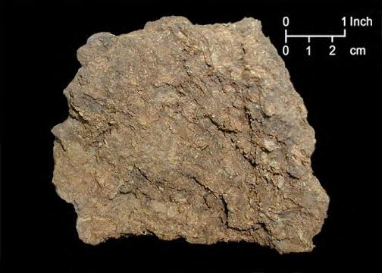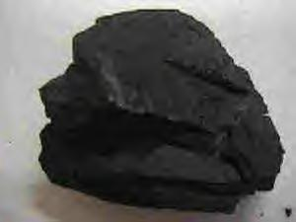
Figure 13.1: Peat Figure 13.2: Lignite
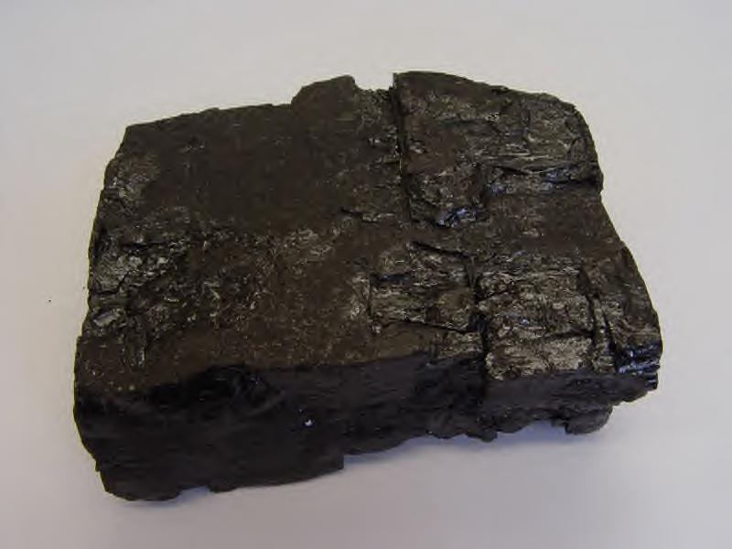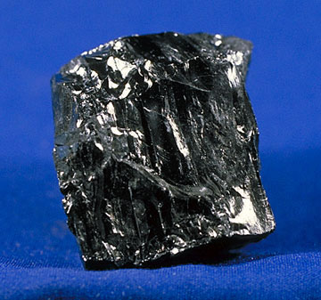
Figure 13.3: Bituminous Figure 13.4: Anthracite

Coal In Rhode Island
The coal found in Rhode Island is extremely variable and ranges from anthracite to graphite. It generally contains a moderate to high amount of ash and a high percentage of moisture when it is first mined. Due to these conditions it must be carefully handled when mined to ensure that it can be used for fuel. The coal beds in Rhode Island originally had a medium thickness but pressure forced them to fold and compress, thus pushing the coal into large pockets if not squeezed out all together. As a result of this the coal itself became broken and compressed and eventually mixed with large quantities of rock impurities, such as quartz. Past mining ventures in the Rhode Island area failed to be profitable mainly as a result of three causes: improper and careless preparation of the coal at the mining site, attempted use of coal in furnaces built to handle other specific coal types, and the low duty obtainable from the coal in comparison with other competing coals. (Ashley 1915: 8)
It seems that people have known about the presence of coal in Rhode Island for quite some time. The coal bed located in Portsmouth (bordering Narragansett Bay) appears to have been known as early as 1760. In February of 1768 a patent was granted to individuals who wished to “dig after pit coal or sea coal” (Ashley 1915: 7) that was located on a hill in the back of Providence. It has also been said that during the Revolutionary War British soldiers located in Newport used local coal for heating purposes. In June of 1887 former Rhode Island Governer Lippett stated that his grandfather had attempted to mine Rhode Island coal prior to 1787. (Ashley 1915: 7) This statement leads one to believe that the knowledge of local coal beds was known very early on in the settlement of the state. In 1808 two mines opened, one in Portsmouth and one on the East side of Providence, and a coal bed was discovered a little to the north of Pawtucket. One year later the Rhode Island Coal Company and the Aquidneck Coal Company were founded. According to early reports these companies failed to prepare the coal properly and, therefore, lost a considerable amount of money. In 1835 a group called J. Alexander and Seth Mason & Bros. became interested in the Pawtucket coal bed, and in 1836 they founded the New England Coal Mining Co. However, the coal raised at this mine did not become popular and the company eventually failed. Around the same time the other coal mining ventures in the Rhode Island area came to a standstill as well. As time went on more coal mining ventures were set up, but none became very successful.
The coal beds found in Cranston appear to have been the most successful with large companies such as the New York Carbon Co. taking interest and investing time and equipment into the mining operation. Eventually Cranston developed its own mining company called the Cranston Coal Co., which stayed in business until the early 1900’s. The Portsmouth coal beds stayed active into the early 1900’s although they passed through several transformations. After many years of producing un-profitable coal and periods of inactivity, the Compressed Coal Co. of Boston took hold of the beds and created a briquetting plant. This plant turned out to be profitable and it was eventually taken over by the Rhode Island Coal Co. in 1909.
The coal mined in Rhode Island was generally used for household and industrial use. However, the types of coal mined within the state were extremely hard to burn and prone to producing extreme amounts of smoke so it is very likely that much of the coal burned for household use was imported from out of state. According to George Ashley in Rhode Island Coal, “90 per cent of the people living in the neighborhood [the Rhode Island area] preferred to burn Pennsylvania anthracite.” (Ashley 1915: 39) It has been shown that Rhode Island coal has only 70-80% of the heating power of other anthracite coals, and only 60-70% of the heating power of bituminous coals that were shipped to New England. Rhode Island coal also has only 40% heating efficiency when compared to other coals. These facts combined with its inability to ignite and high percentage of ash lead insight into why Rhode Island coal was never very successful.

Coal in an Archaeological Context
When coal is discovered within an archaeological context it can tell us several things. Most importantly, it gives the archaeologist a means of dating the site. Coal was first produced in the United States in 1748 in the Mankin, Virginia area. In light of this, if coal is found within an archaeological site it is safe to say that the site is post-1748. By determining the type of coal that is found, the archaeologist can also attempt to date the site more precisely as the different types of coal were first mined at slightly different times. The type of coal found within a site is also helpful in determining how people traded during the given time. Different types of coal are specific to different locations around the country, so by determining the type of coal the archaeologist is able to shed some light on where and how people were trading. The coal mined in Rhode Island is extremely hard to burn and is prone to exploding once it is ignited. As a result, most coal found in archaeological sites in Rhode Island was probably imported from another mining location.
Coal is generally used by people as an energy and heat source, as well as for cooking. Finding coal within an excavation can give evidence as to what type of stoves and furnaces people were using and perhaps what they were using them for.
The coal found in Rhode Island is typically Anthracite, which is the hardest of all the coal types (excluding graphite). In light of this, it is not necessary to spend extra time bagging and preparing it in the field as it is extremely durable. However, special attention should be paid to the depth and exact location of the coal within the excavation unit, as well as documentation of the exact amount found. This information is important because it can give the archaeologist insight into what the coal was being used for and how it came to be in its present location.

Coal At The First Baptist Church
Coal was first used as fuel in the First Baptist Church when coal stoves were installed in the auditorium of the meeting house in 1826. Coal continued to be the main source of fuel for the Church well into the 20th century until the coal stoves were replaced with oil burners and eventually gas furnaces. During the excavation of the First Baptist Church property we uncovered quite a bit of coal (bituminous and anthracite). The following is a chart which shows the amount of coal found, the test pit location, and the depth at which it was uncovered.
Test Pit Number and Lot Number | Bituminous Coal | Anthracite Coal
FBCA1
Lot 2 (10-20cm) | 1g | 41g
Lot 3 (20-30cm) | .3g | 35.1g
Lot 8 (70-80cm) | 7g | -
Lot 9 (80-90cm) | .3g | -
FBCA2
Lot 2 (10-20cm) | 3g | -
Lot 3 (20-30cm) | 4g | 2g
FBCA3
Lot 1 (0-10cm) | 3g | 2g
Lot 2 (10-20cm) | 6g | 3g
Lot 3 (20-30cm) | - | 1g
FBCA4
Lot 3 (20-30cm) | - | 1g
Lot 4 (30-40cm) | 36.6g | -
FBCB1
Lot 2 (10-20cm) | 5.2g | -
Lot 4 (30-40cm) | - | 1g
Lot 6 (50-60cm) | - | 5.2g
Lot 7 (60-70cm) | 8g | -
FBCB2
Lot 2 (10-20cm) | 48g | 3g
Lot 3 (20-30cm) | 54g | 5g
Lot 4 (30-40cm) | 43g | 21g
Lot 5 (40-50cm) | - | 1 piece less than a gram
FBCB3
Lot 2 (10-20cm) | 3g | 3g
Lot 3 (20-30cm) | 6.4g | -
Lot 4 (30-40cm) | - | .2g
Lot 5 (40-50cm) | 30g | -
FBCB4
Lot 4 (30-40cm) | - | .3g
Lot 5 (40-50cm) | .9g | -
Lot 3 (20-30cm) | - | 1 piece less than a gram

Table 13.2: Amount of coal found within each test pit.

Photographs of Excavated Coal from the FBC Property

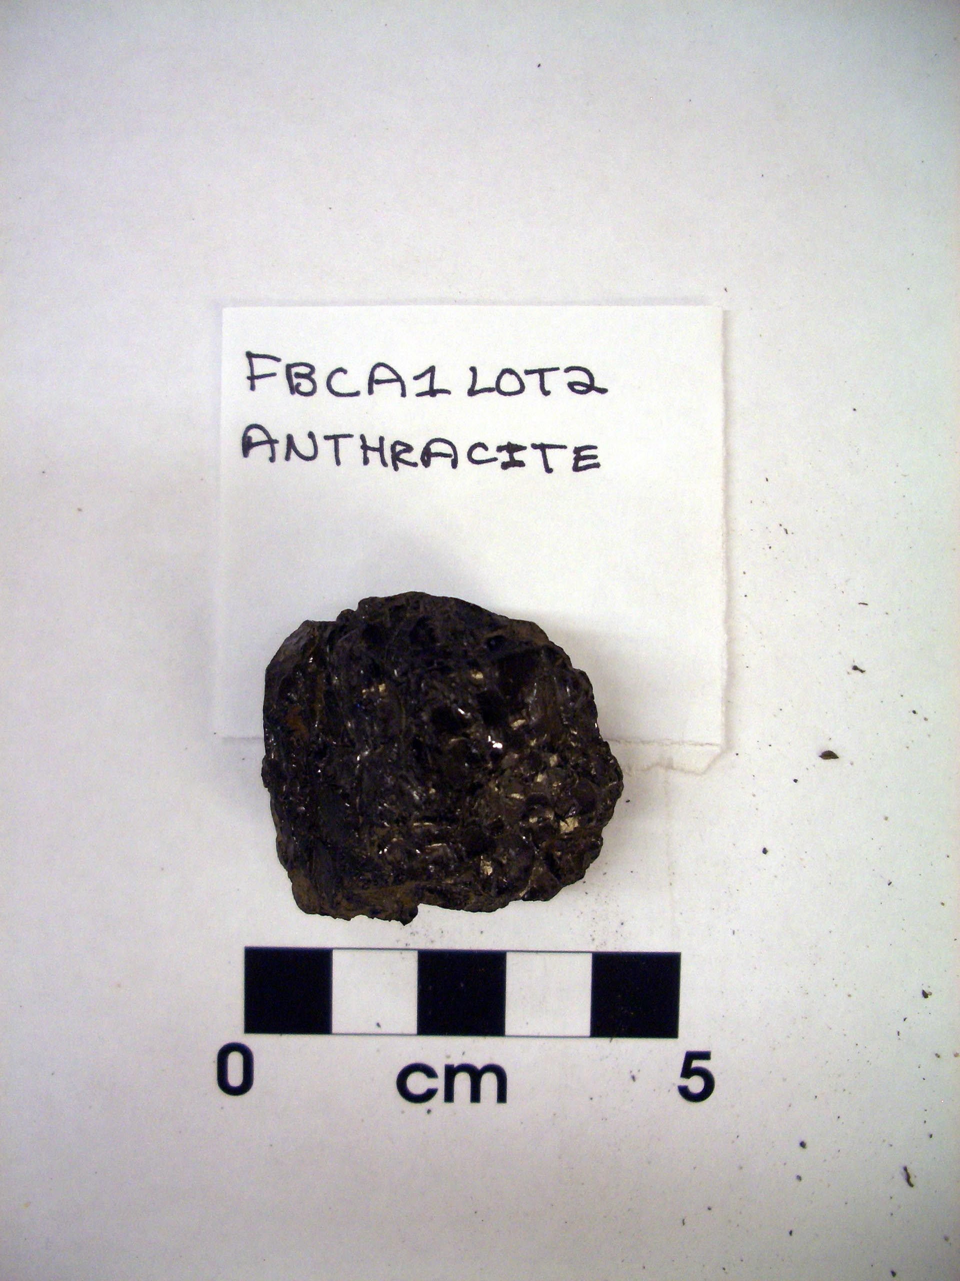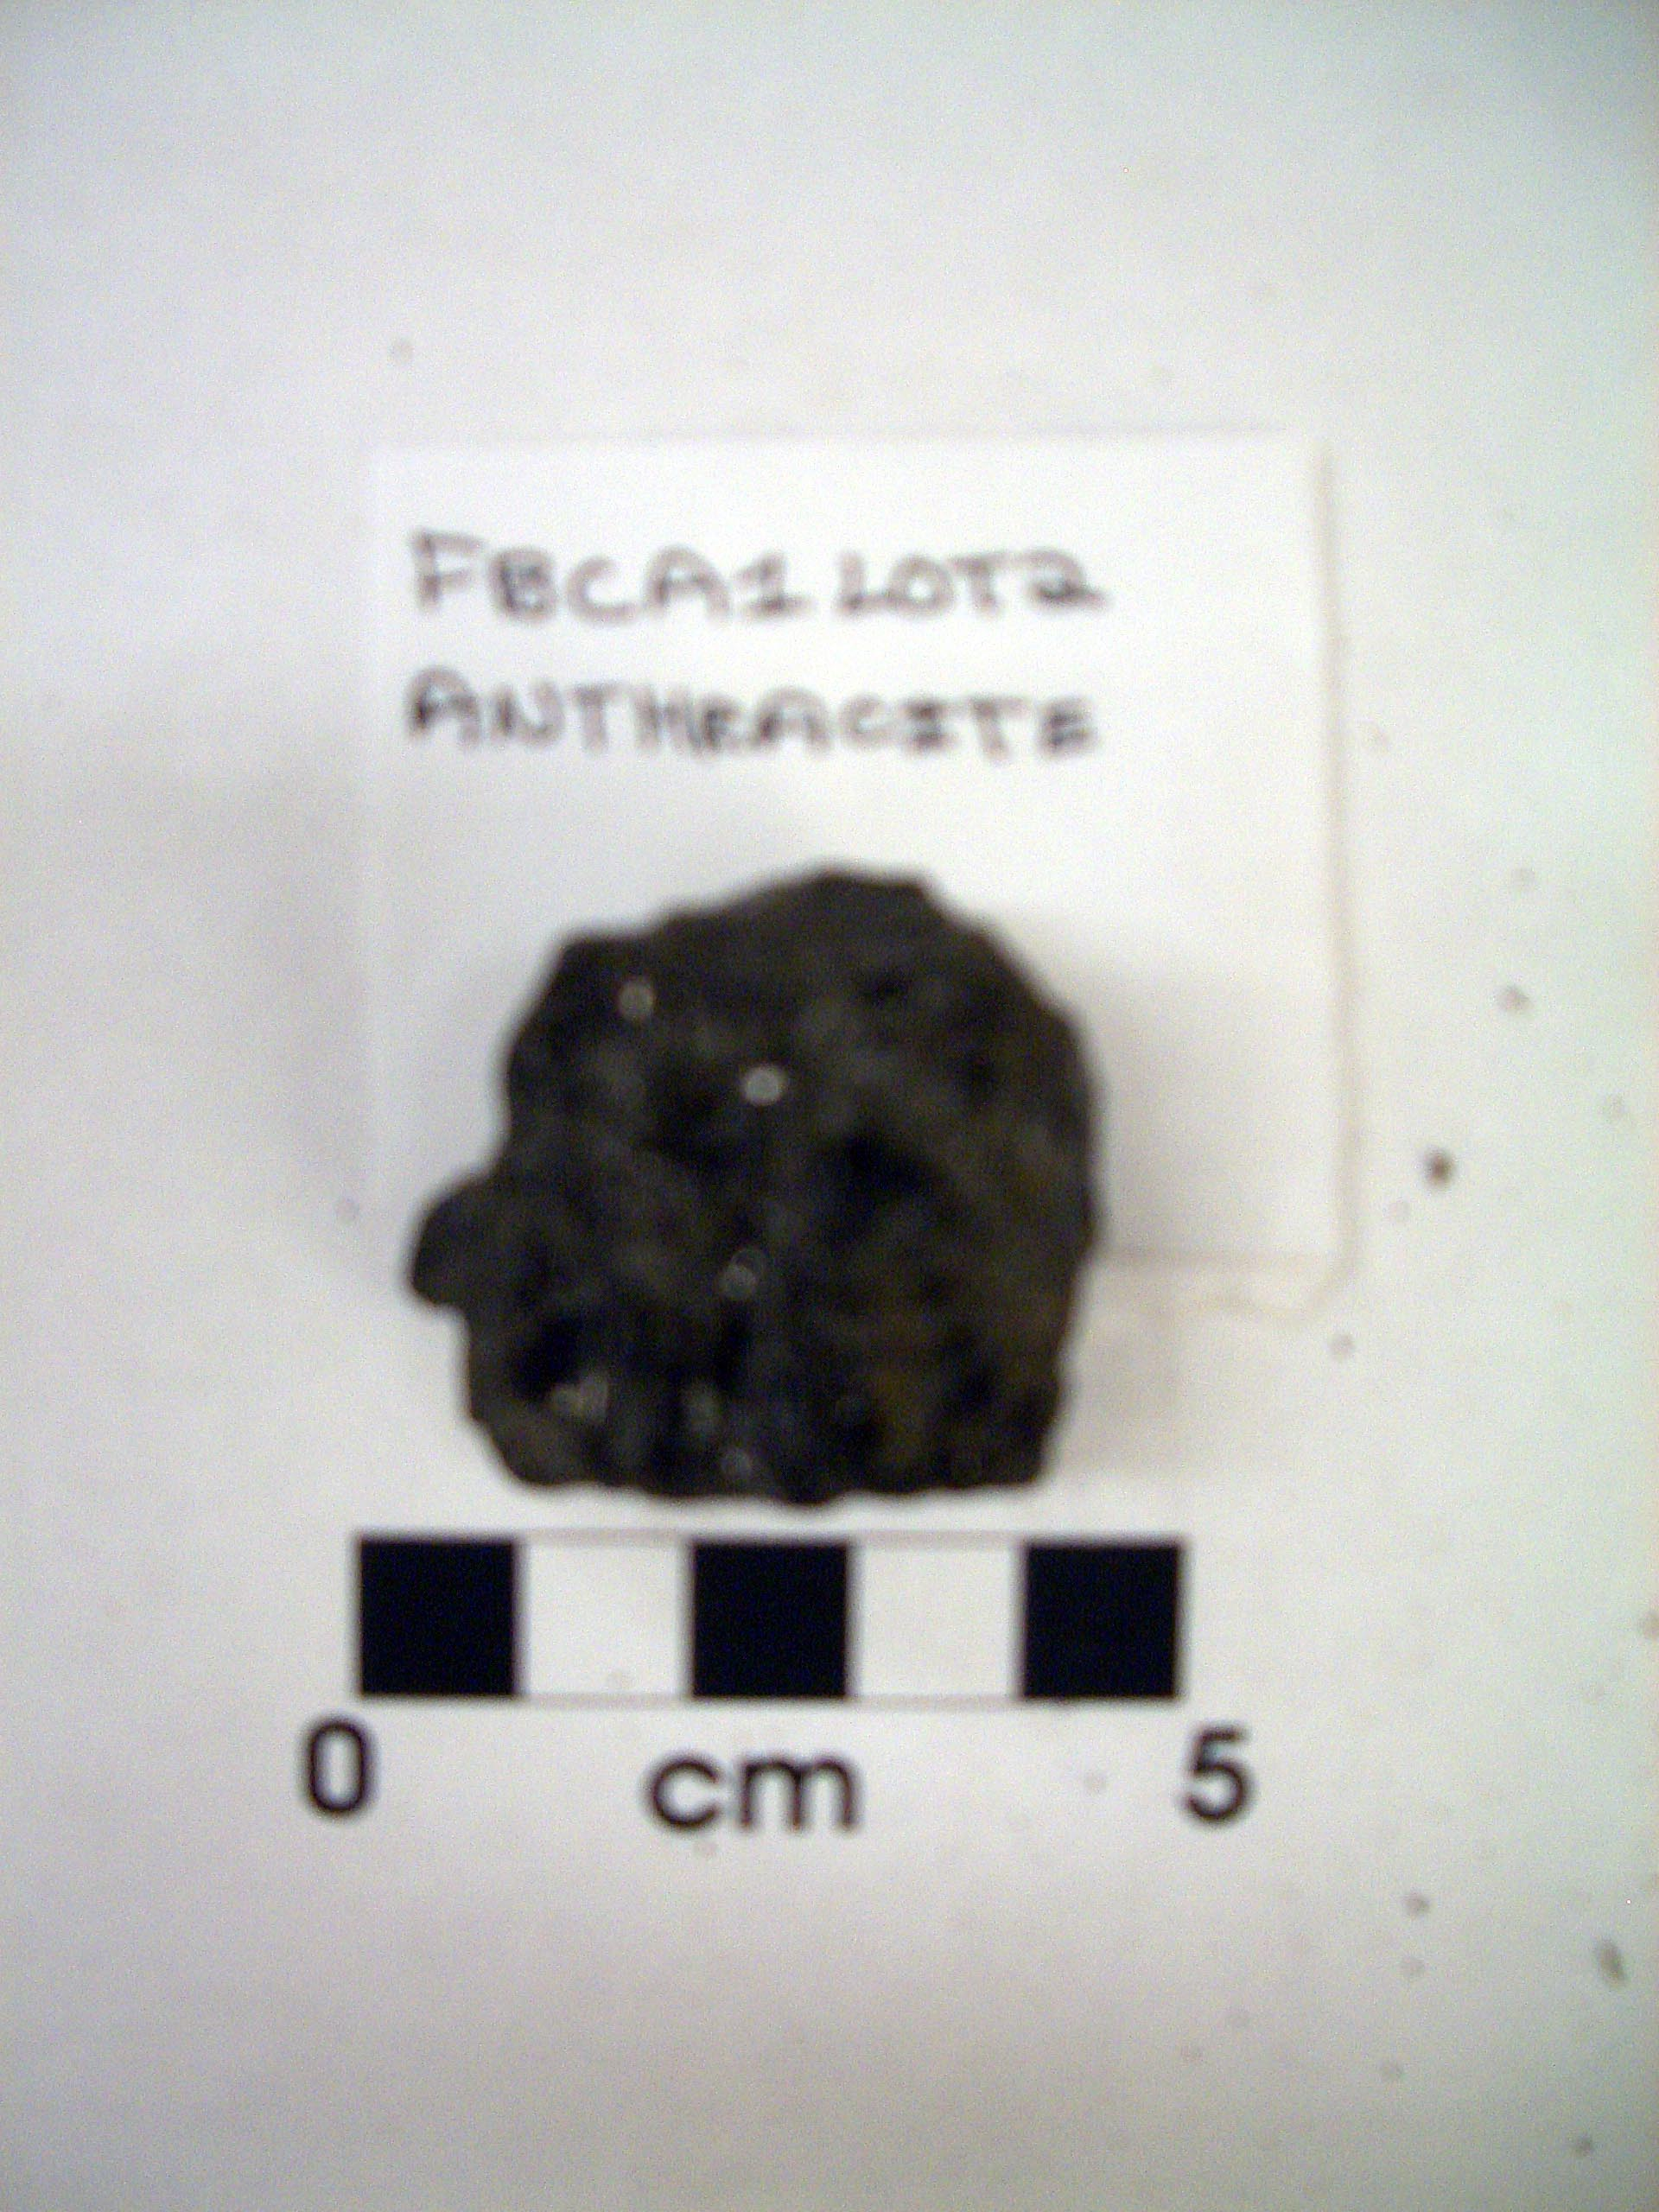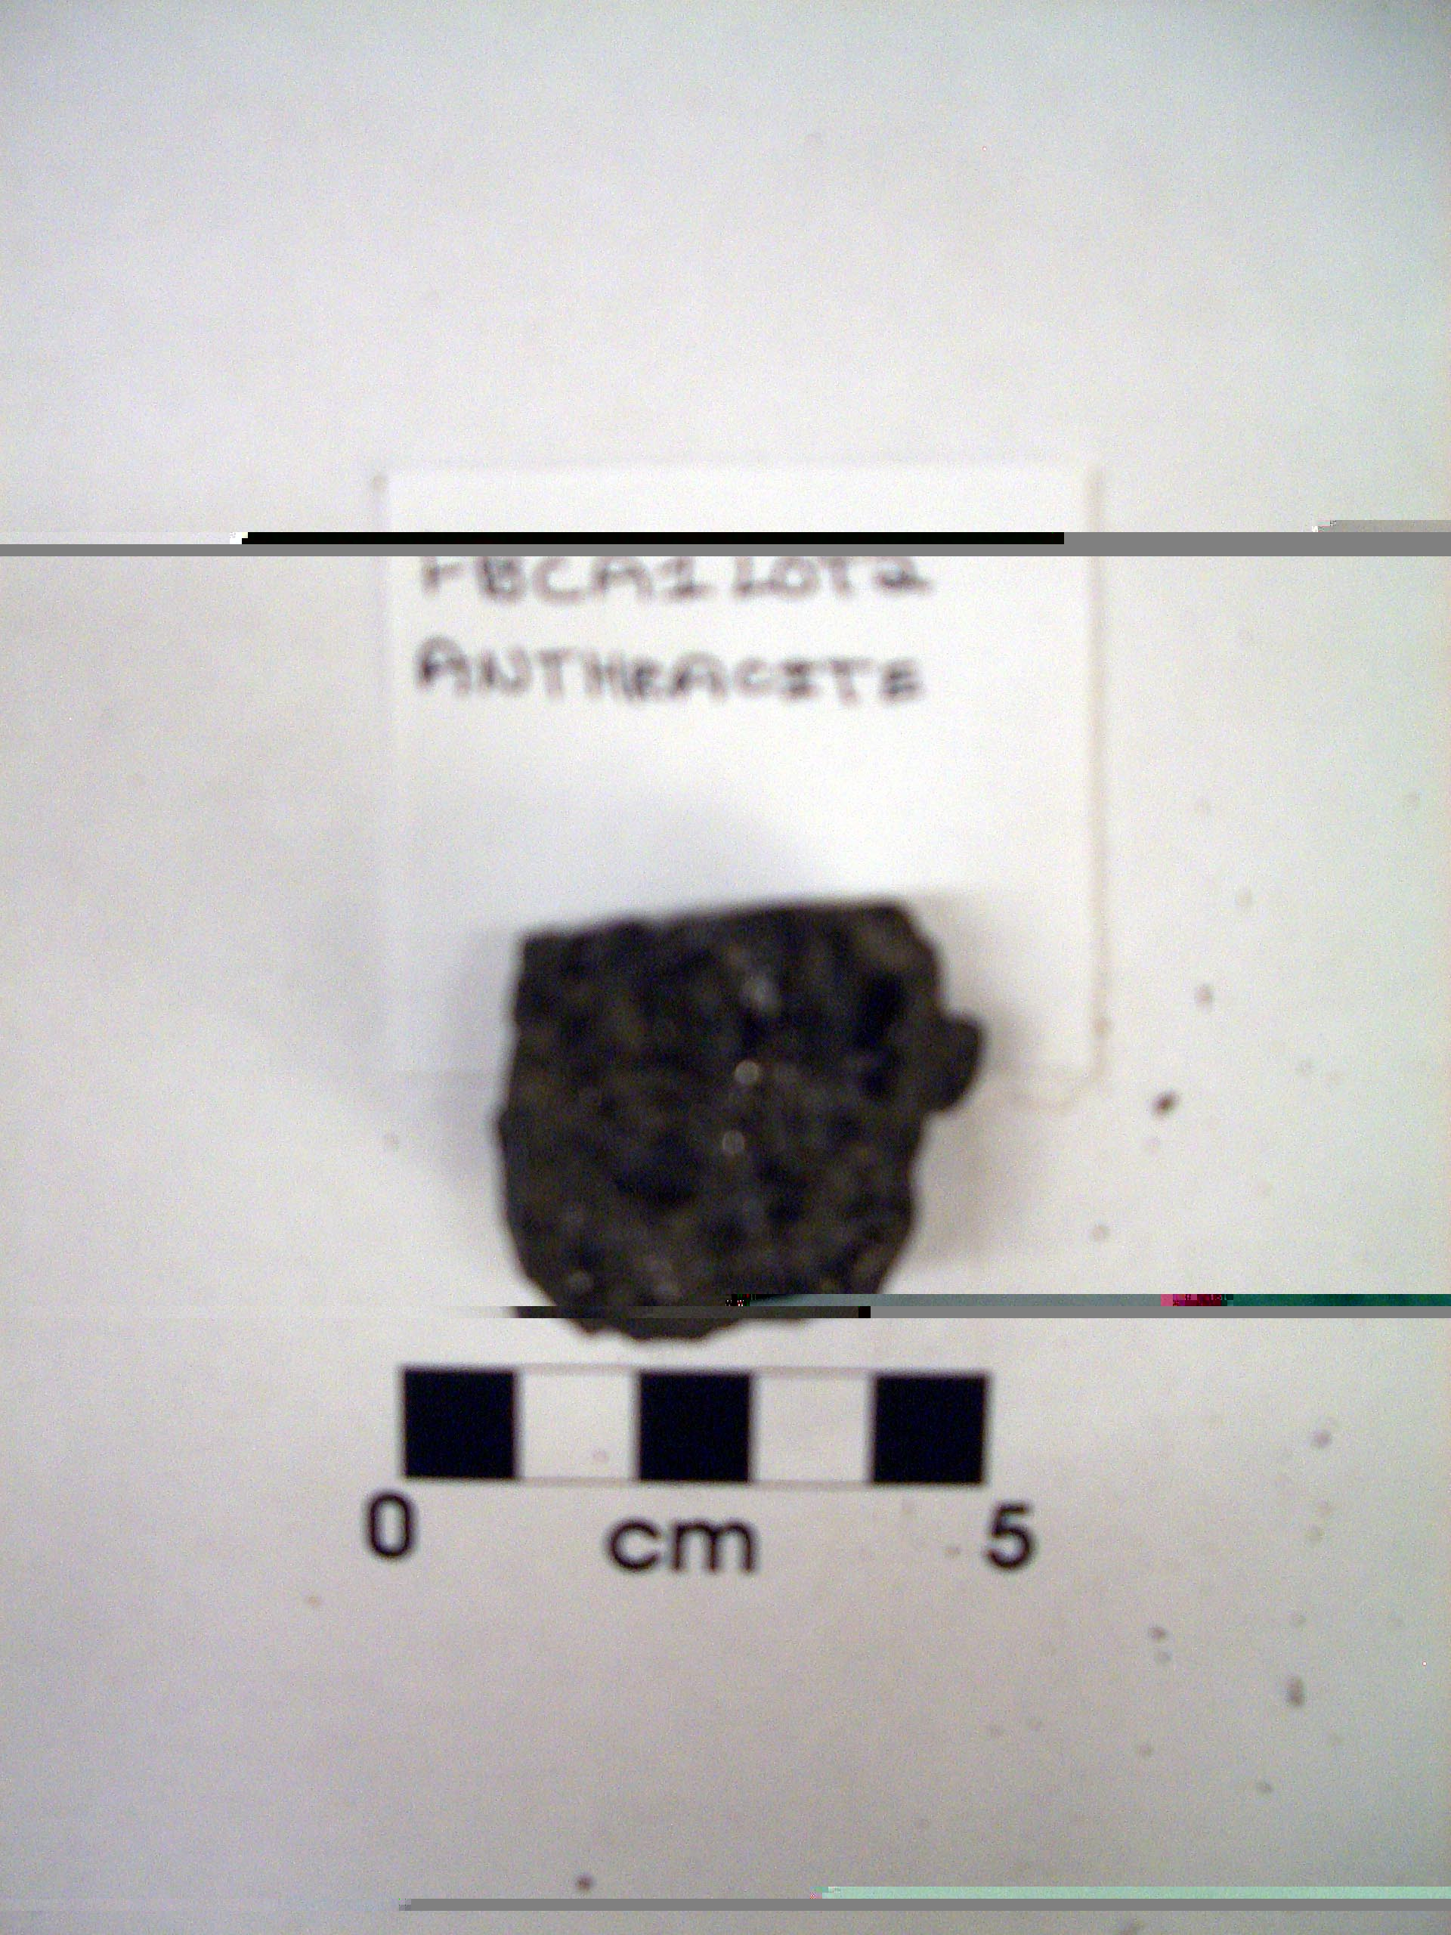
Figure 13.5 Figure 13.6 Figure 13.7
Figures 13.5, 13.6, 13.7: Anthracite from FBCA1 Lot 2

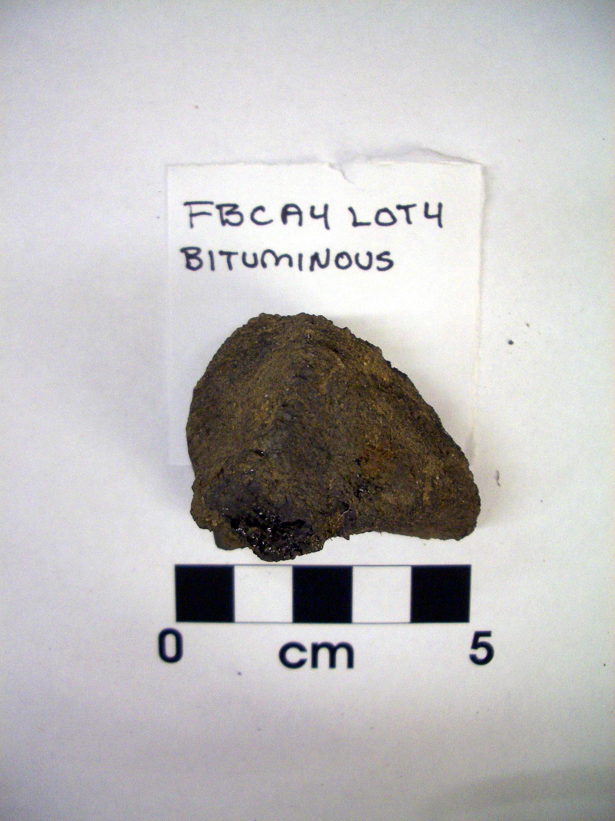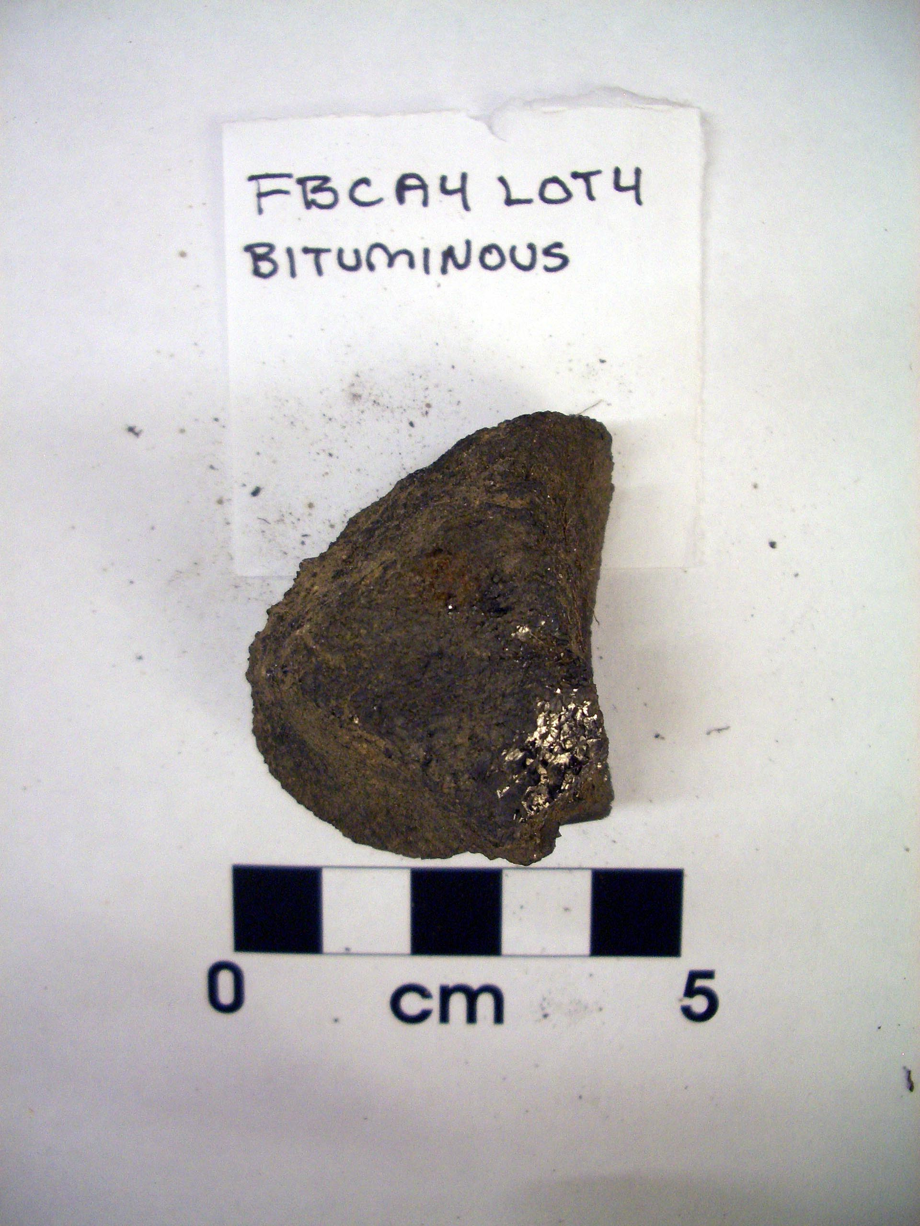
Figure 13.8 Figure 13.9 Figure 13.10
Figures 13.8, 13.9, 13.10: Bituminous coal from FBCA4 Lot 4

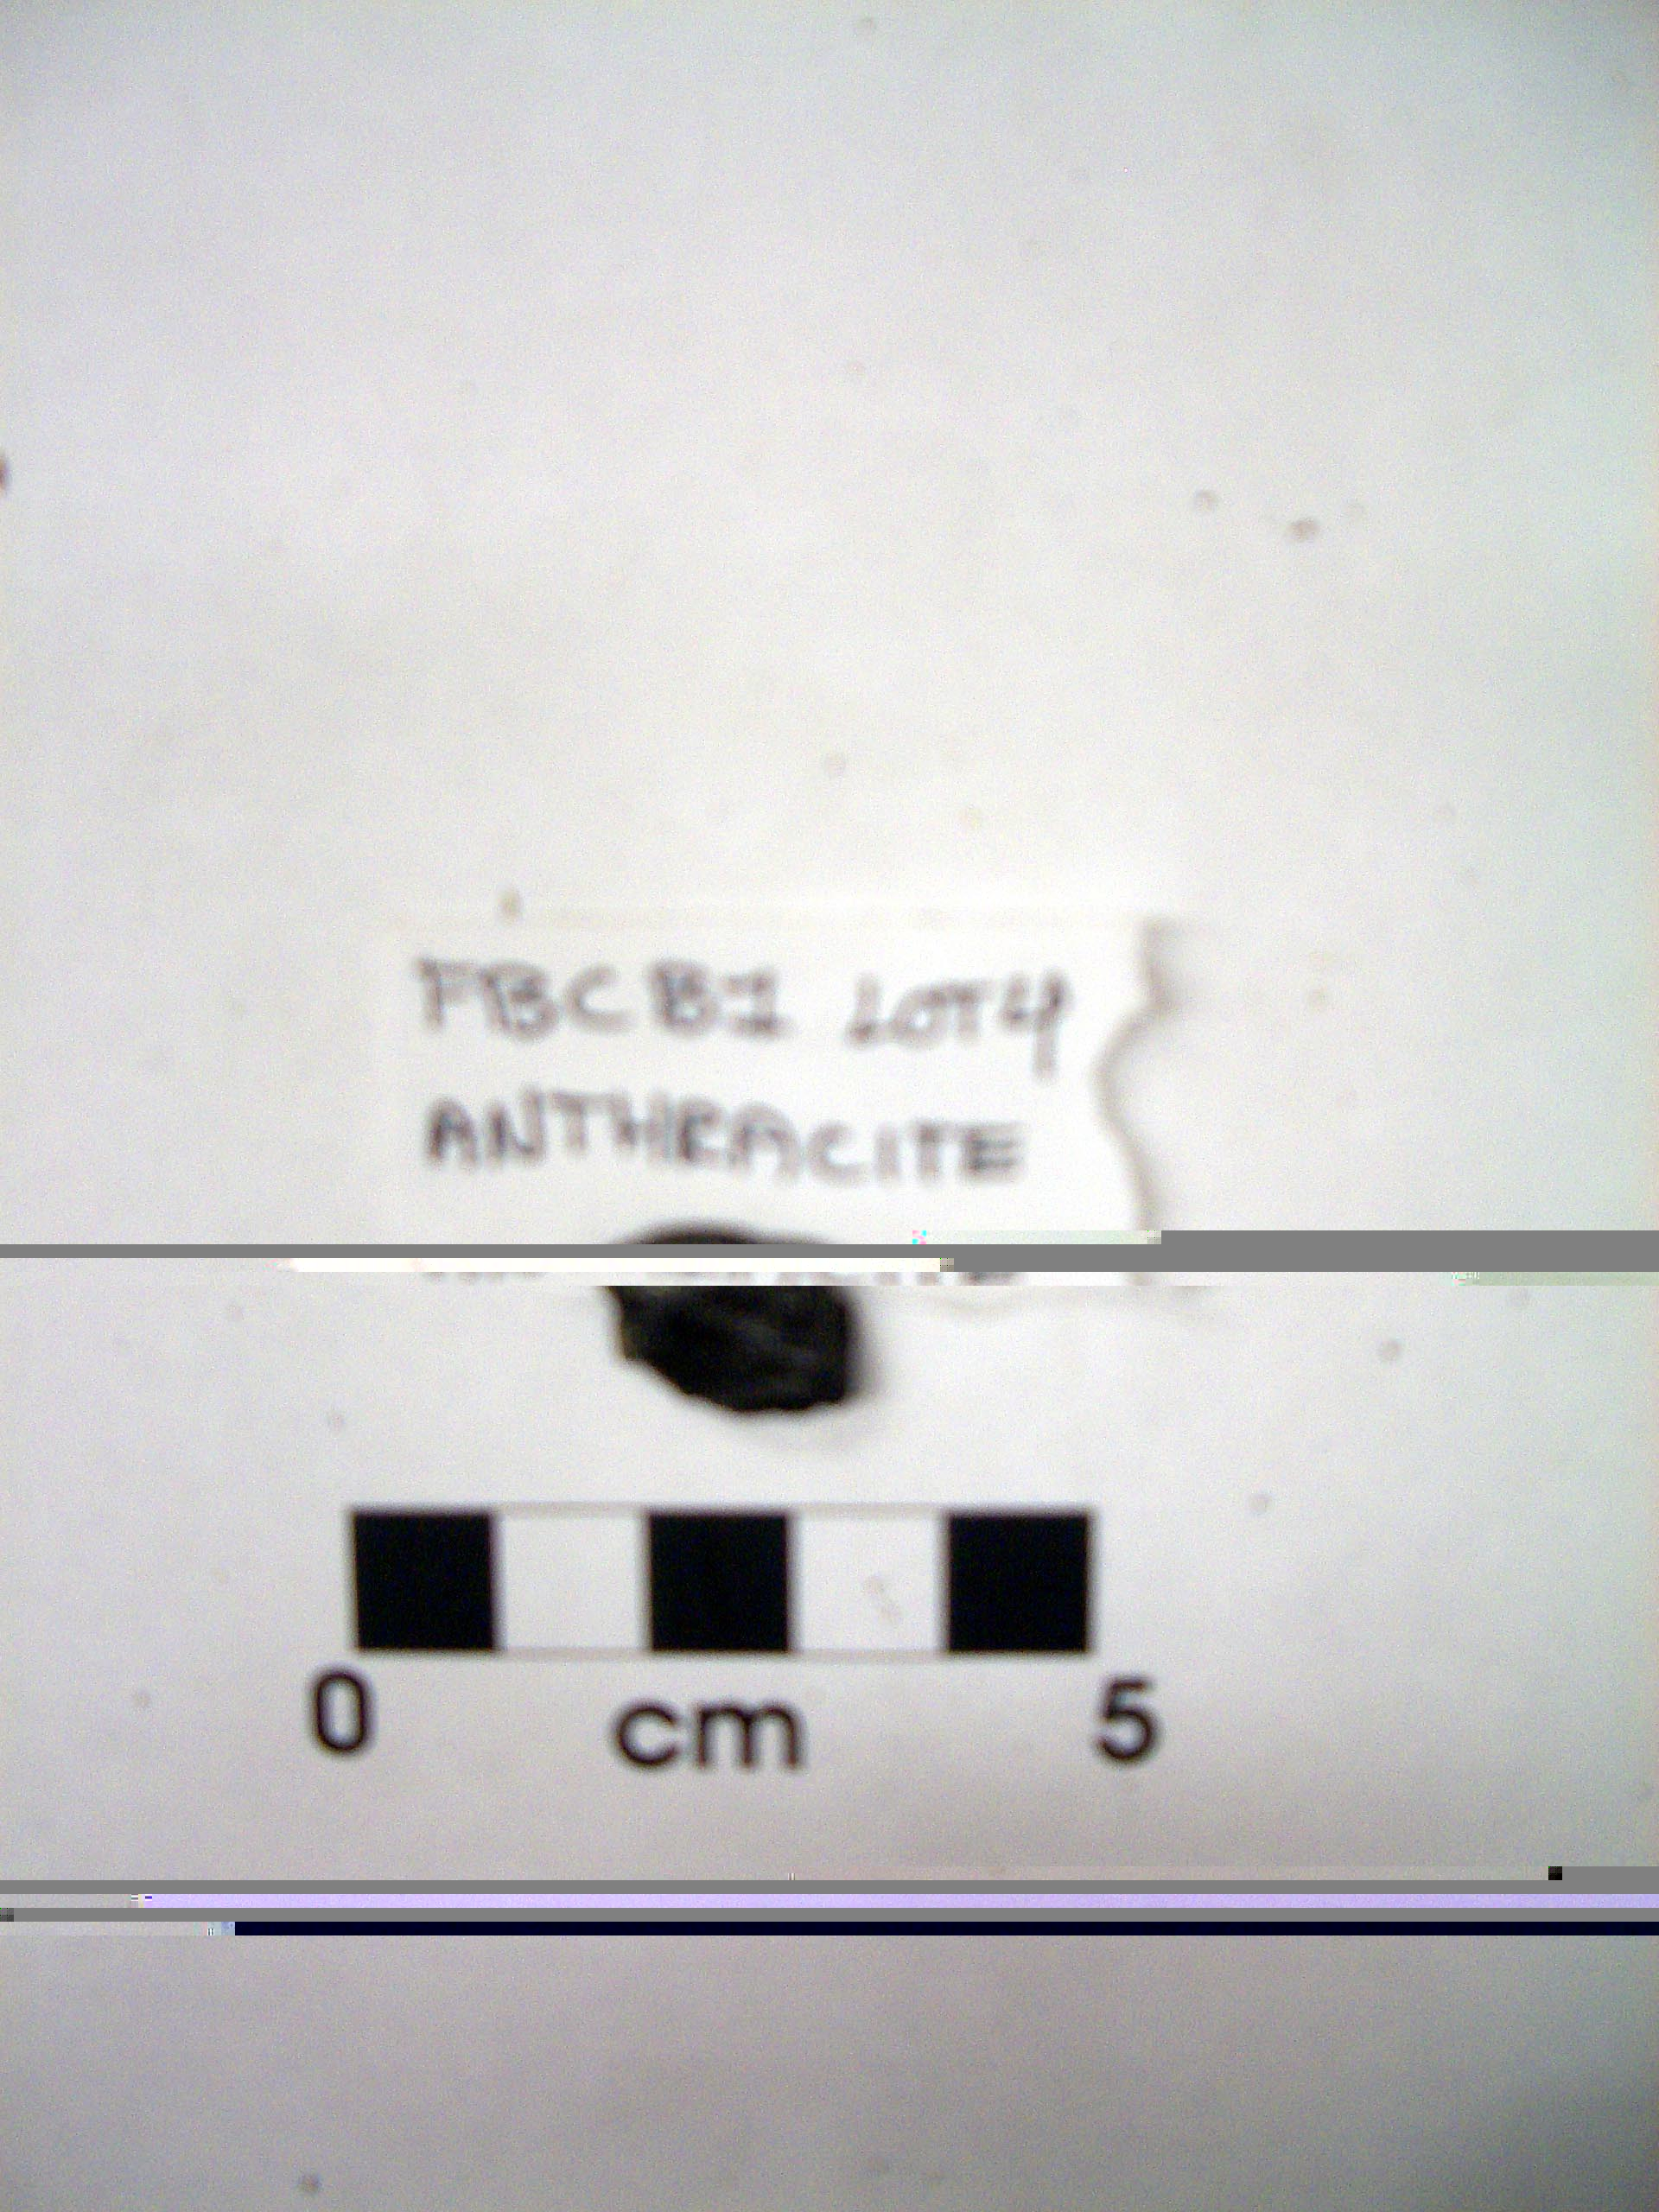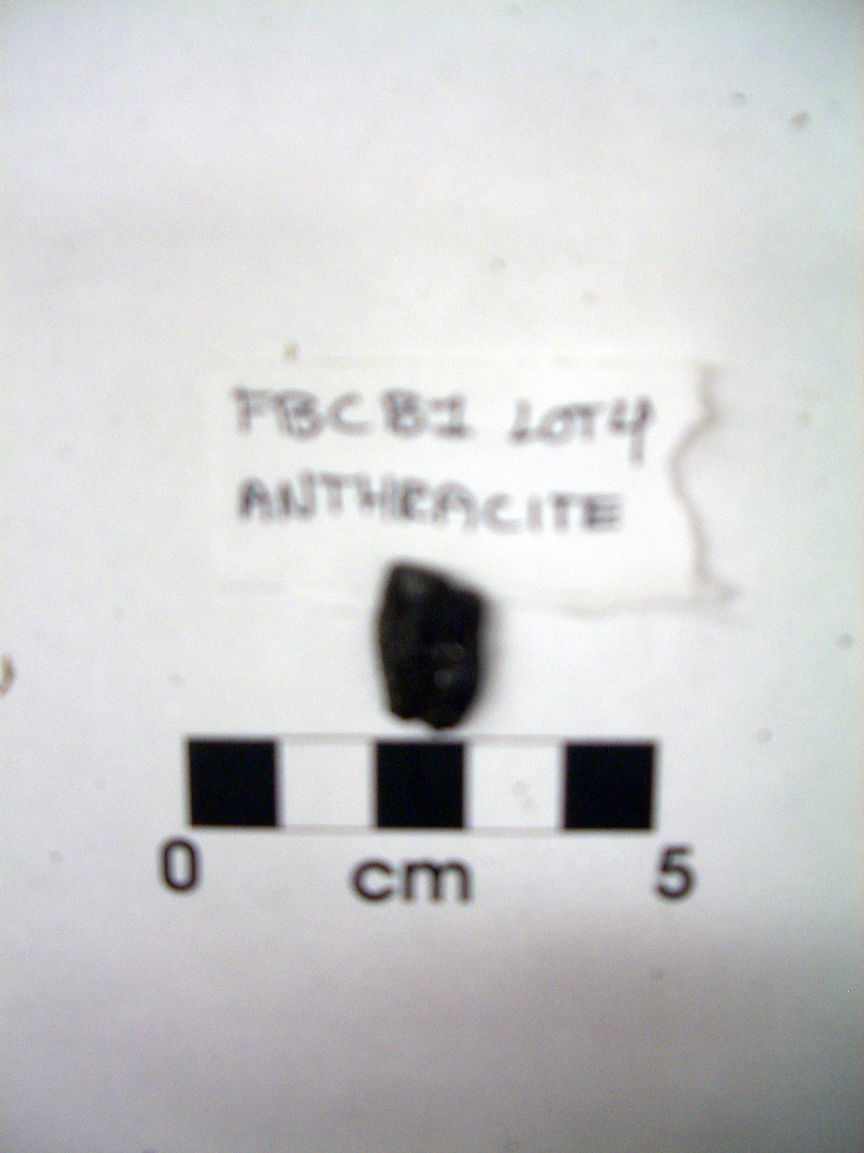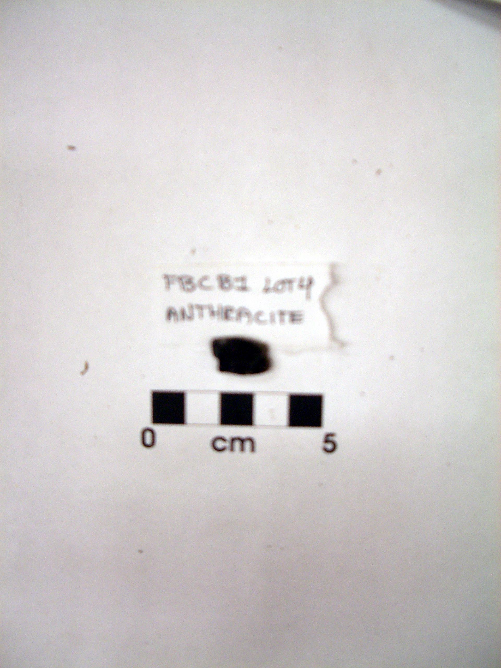
Figure 13.11 Figure 13.12 Figure 13.13
Figures 13.11, 13.12, 13.13: Anthracite from FBCB1 Lot 4

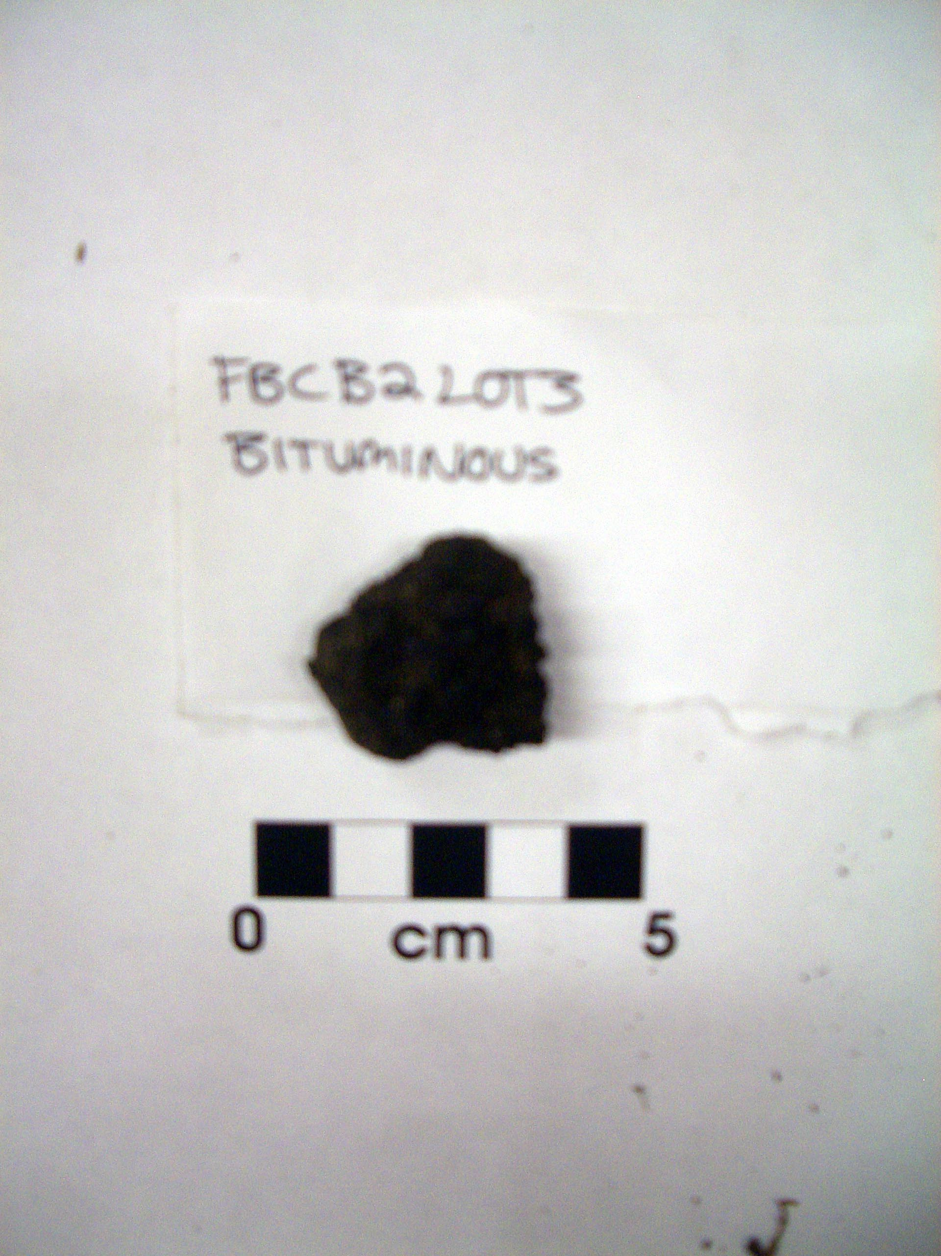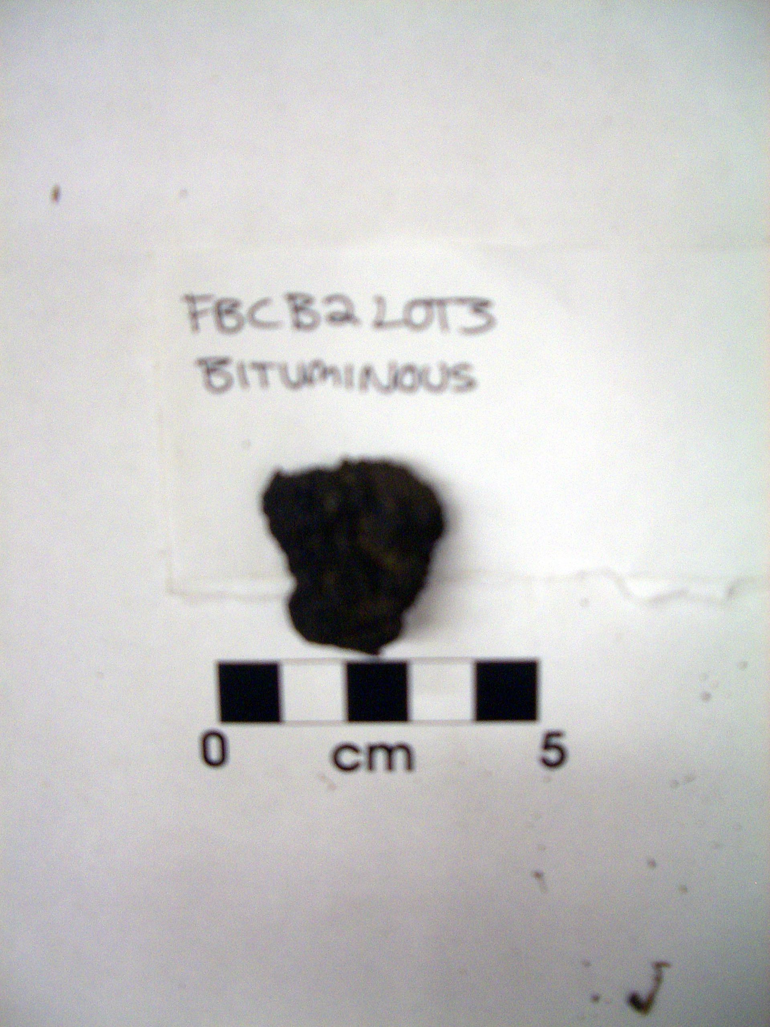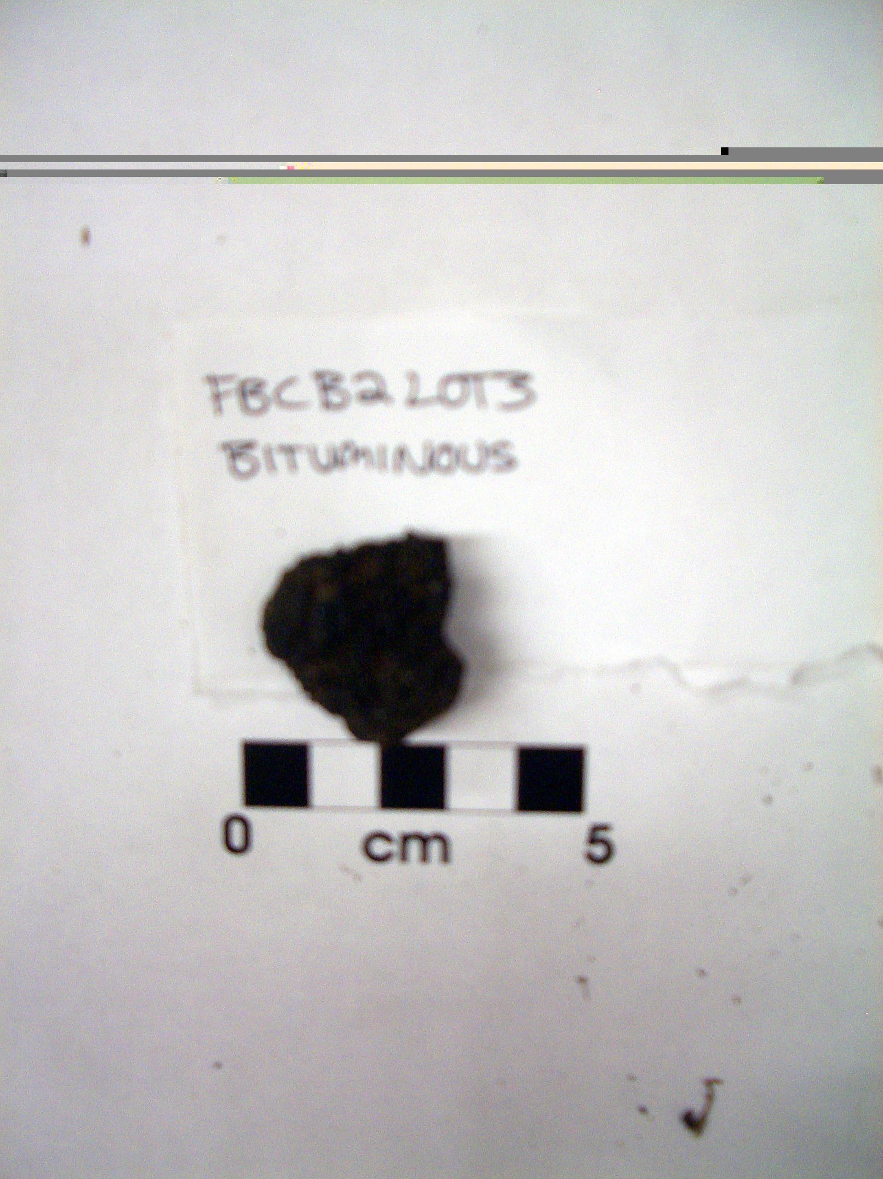
Figure 13.14 Figure 13.15 Figure 13.16
Figures 13.14, 13.15, 13.16: Bituminous coal from FBCB2 Lot 3

Bibliography

Ashley, George H.
1915 Rhode Island Coal. Department of the Interior United States Geological Survey:
Government Printing Office, Washington.
Hatt, Rod
2003 Coal and Slag as an Archaeological Artifact. Presented to SHA Conference in
Providence, RI in 2003.
http://www.coalcombustion.com/coal_and_slag_arch1.htm
Heizer, Robert F.
1958 A Guide To Archaeological Field Methods. The National Press, California.
Phillips, Patricia
1985 For the Council for British Archaeology. The Archaeologist and the Laboratory. The
Gresham Press, Surrey.
Sutton, Mark and Brooke Arkush.
1998 Archaeological Laboratory Methods: An Introduction, Second Edition. Kendall/Hunt
Publishing Company, Iowa.

***UNSURE OF PROPER FORMATTING FOR THE LAST TWO***

United States Geographical Survey, Classification of United States Coals (Pre-1923)
http://energyconcepts.tripod.com/energyconcepts/classification_of_us_coals.htm

Special thanks to Professor Stanley Lemons for information on the coal use of the First Baptist Church.

All subsequent material involving context and origins of coal summarized from Ashley (1915) and http://energyconcepts.tripod.com/energyconcepts/classification_of_us_coals.htm
Peat is an accumulation of partially decayed organic matter which, under the right conditions, can become the earliest stage in the formation of coal.
Graphite is considered to be the highest grade of coal but it is not normally used as fuel since it is difficult to ignite.
Briquettes are dried and compressed lignites that are formed into hard rocks which can be used as a means of combustion.

